Free Movie in the Park
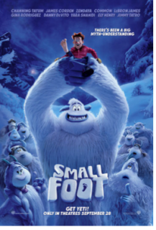
Small Foot
Rated G
July 24, 2021
6:00 p.m.
Royer Park
190 Park Dr.
Enjoy an evening in the
park with family, friends,
and neighbors!
Events start at 6:00 p.m. Come for dinner. Authentic Street Taco truck, Snowie King Hawaiian Ice, Kelli’s Cookies and popcorn. Come to the RCONA booth to spin the wheel and win a free item from one of the food trucks.
Entertainment provided by Sons of the Golden State band. Music consisting of country, bluegrass, patriotic, and rock.
Police and Fire will be there to greet children and answer your neighborhood questions.

Movie begins at sundown on a 30 ft. screen (weather permitting -
check: rcona.org). Closed Captioning available on request.

Participants are asked to follow current CDC guidelines for COVID 19.

Park rules: No Smoking, No Alcohol, No Dogs

